# Purpose

The purpose of this document is to describe the design of a reference implementation that integrates OpenXC ([www.openxcplatform.com](http://www.openxcplatform.com)) with MOTECH (<http://motechsuite.org/>) . See the following documents for the specific extensions and APIs to the two platforms – OpenXC_Backend_Developer_Reference_v1.docx and MOTECH_Vehicle_Extension_Developer_Reference.docx. In addition, detailed setup instructions for MOTECH are available in a separate document – mHealth-MOTECH_Setup.docx.

# High-Level Architecture Overview

Figure 1 depicts an overall solution and execution flow to develop applications using “OpenXC - MOTECH framework”.

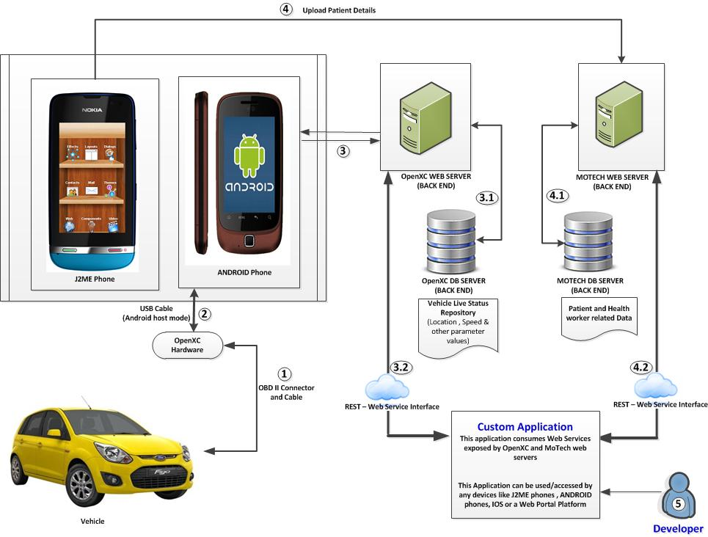

Figure 1. Architecture Diagram for the Integration Framework

**Below are the key steps**

 A car (or vehicle) is connected to OpenXC Vehicle Interface via OBD-II port. Further details are available at [www.openxcplatform.com](http://www.openxcplatform.com).

 OpenXC (Interface) connected with Android device/phone by using USB cable or Bluetooth.

 Vehicle data (like engine speed, location, timestamp etc.) uploaded into OpenXC backend (web server) via Android device

 “OpenXC web server” connects with “OpenXC Database server” to load the **vehicle** data like speed, location and other parameters.

 REST (web service interface) used to connect “OpenXC web server” with custom application which is deployed in any device like Android, J2ME and IOS etc.

 J2ME phone connected to “MOTECH web server” (backend) to load the patient t and health worker related data

 “MOTCH web server” connects with “MOTECH Database” to load the **Patient** and **health worker** data.

 REST (web service interface) used to connect “MOTECH web server” with custom application which is deployed in any device like Android, J2ME, and IOS etc.

 Developer can use the above APIs to develop health applications. This custom application could consume web services from both “OpenXC” and “MOTECH” web servers.

“Web services” used to support platform independent (i.e.) custom application developed by the developer should be supported by any devices like Android, J2ME.